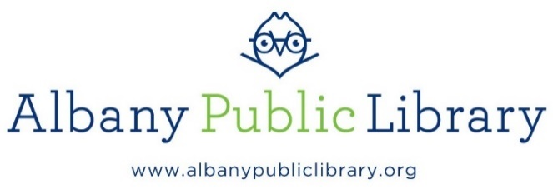

Job Title: Part Time Library Clerk

Classification: Library Clerk

Location: Bach Branch

Reports to: Bach Branch Manager
Updated: July 1, 2025
External Posting

General Statement of Duties:
Under supervision, an incumbent in this class performs routine clerical library work at the Albany Public Library. Work is primarily routine in nature and involves standard clerical tasks in support of the operation of the library. Work involves using automated office systems. Supervision is not a requirement of this position.

Job Description:
- Performs routine library clerical duties
- Organizes and distributes library materials
- Provides direct service to the public
- Opens and sorts library materials
- Enters and retrieves information in an automated information system and point of sale systems, prepares invoices and other order forms, and files cards
- Assists in maintaining an adequate inventory of books and supplies
- Prepares material for addition to the library’s collection and for shelving
- Labels library materials in accordance with established procedures
- Secures special books and other library materials as requested
- Repairs library materials
- Provides information to readers and library users and assists them in the use of the automated library systems and audio-visual equipment
- Sets up audio-visual equipment and provides support during library programs
- Distributes books, periodicals, media, etc., at the circulation desk
- Performs stack maintenance
- Other duties as assigned

Required Skills and Abilities:
- Demonstrates strong interpersonal skills, particularly tact and courtesy in dealing with the public
- Works independently and as a team
- Shows working knowledge of general office procedures
- Ability to use personal computers and office equipment
- Ability to understand and follow oral and written instructions
- Assist others in the use of library facilities, including automated system
- Physical condition commensurate with the demands of the position.

Minimum Qualifications:
Possession of a high school or equivalency diploma and either:
(A) One (1) year of general clerical experience after graduation; OR
(B) Six (6) months of customer service or retail experience; OR
(C) Satisfactory completion of 30 credits* at a recognized college or business school; OR
(D) A satisfactory equivalent combination of training and experience as defined by the limits of (A) and (C) above.

*SPECIAL NOTE: Education beyond the secondary level must be from an institution accredited or recognized by the Board of Regents of the New York State Department of Education as a post-secondary degree-granting institution.

Work Schedule: A combination of day, evening and weekend hours up to 28 hours per week is required.

Salary: $16.81/hr

Deadline: Monday, July 14, 2025

Apply to: Send cover letter, resume and 3 professional references including email to:
Human Resources
hr@albanypubliclibrary.org

